**Smart Class Room**

1. Room No 26.

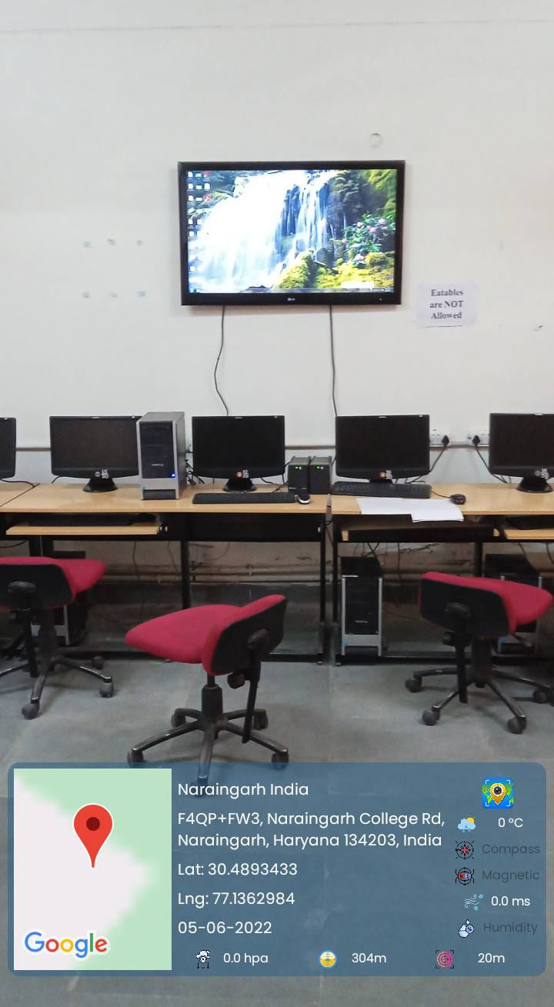

1. SCR

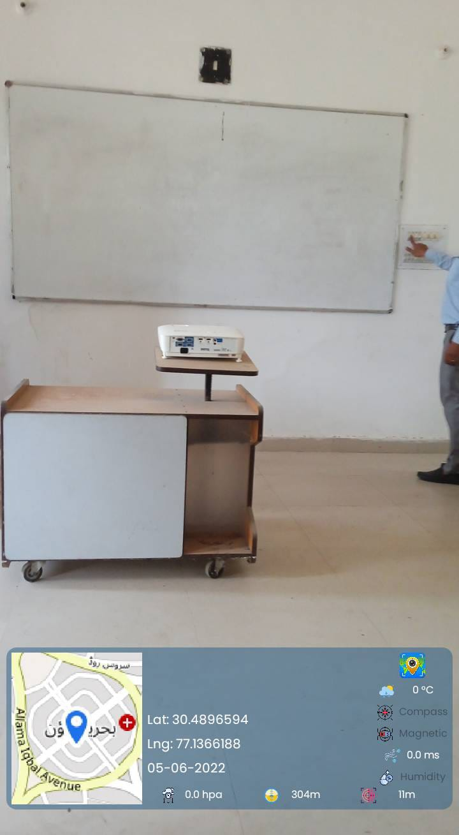

**Seminar Hall**

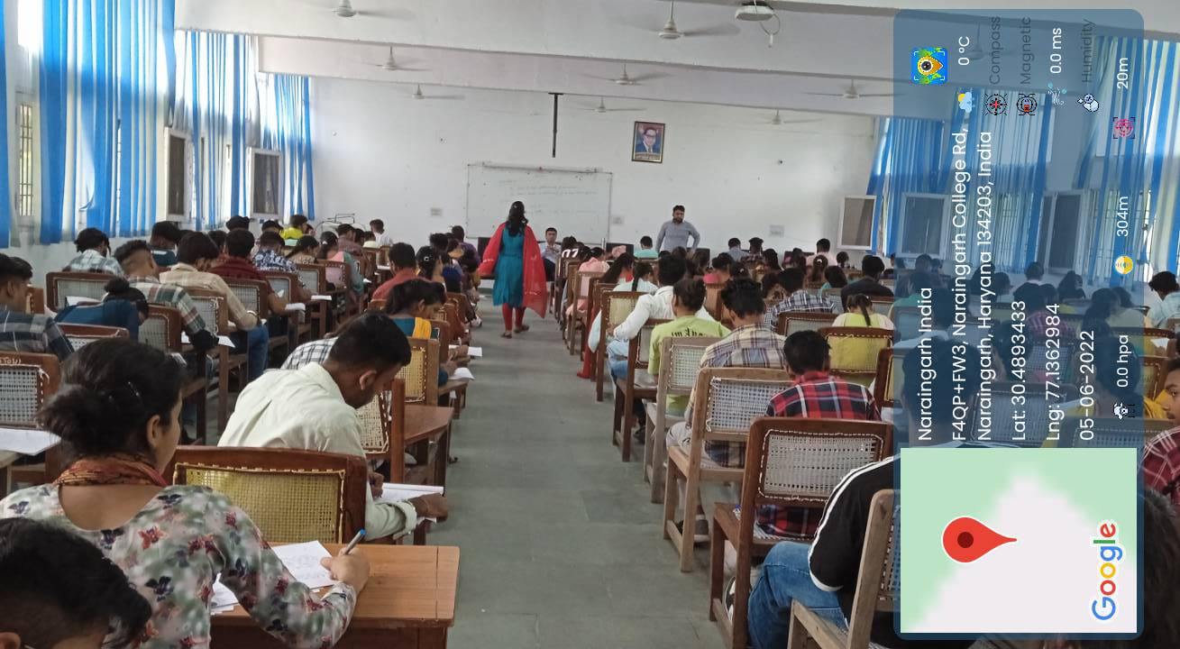

Multi-Purpose Hall

|  |
| --- |
|  |
|  |

Gymnasium & Sports

|  |  |
| --- | --- |
|  |  |
|  |  |